Week: Term 2, Week 7
Day/Date: Wednesday 2nd Thursday 3rd June 2021
Class: 7
Topic: Science (sustainable resources - continued)

Completed | Suggested Time | Learning Activity | Student Action
Please note, all textbook pages referred to for this checklist have been provided in this word document.

 | 10-15 min | Sustainable resources – skim reading  Skim reading strategy:  - Try to remember as many ideas as you can from these pages.  - Read the headings and first sentences of paragraphs. You may also want to read the last line of each paragraph.  - Try and add at least three ideas or extra pieces of detail to what you remembered in step 1. | - Refresh yourself with what you learned in the first checklist by skim reading ‘6.2 Sustainable resources’ again  - Pages 138 (top half of page), 139 (top half of page), 141 and 143.
 | 15min | Sustainable resources - questions | - Complete ‘Check’ questions 1 - 8 (in the blue box on page 145)
 | 15 min | Science as a Human Endeavour – George Washington Carver (1864-1943) | - Read ‘Science as a Human Endeavour’ on page 142.  - Complete Questions 1-5.

READING
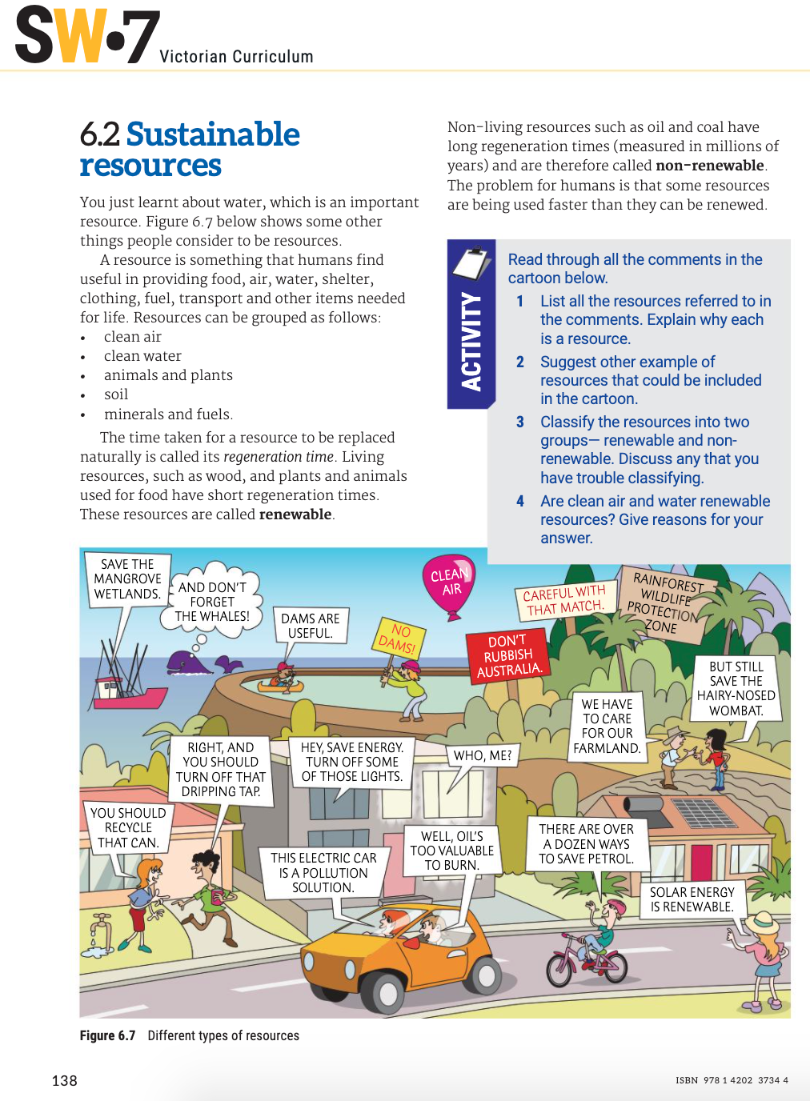
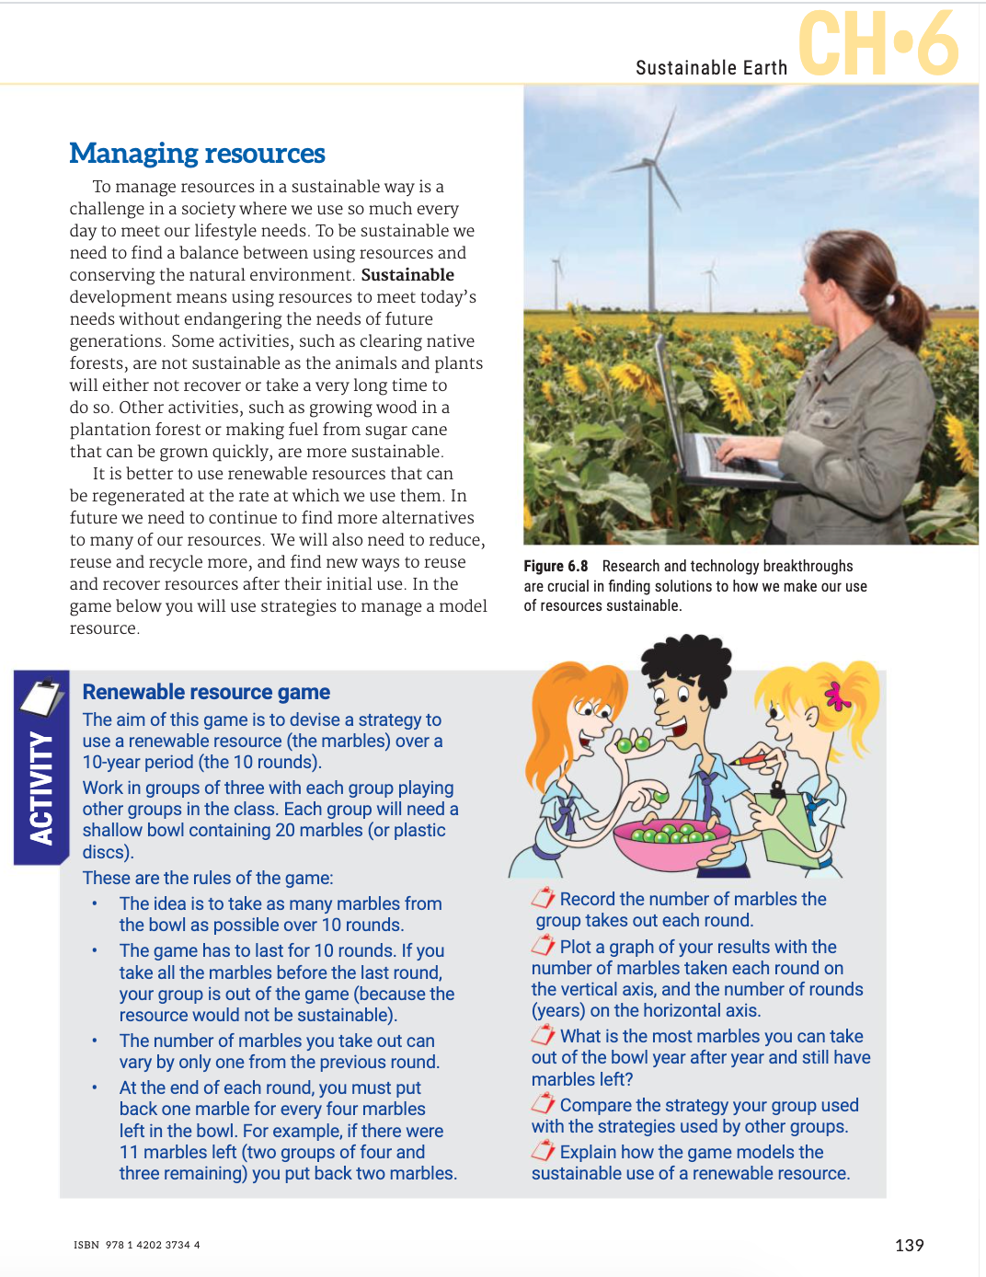
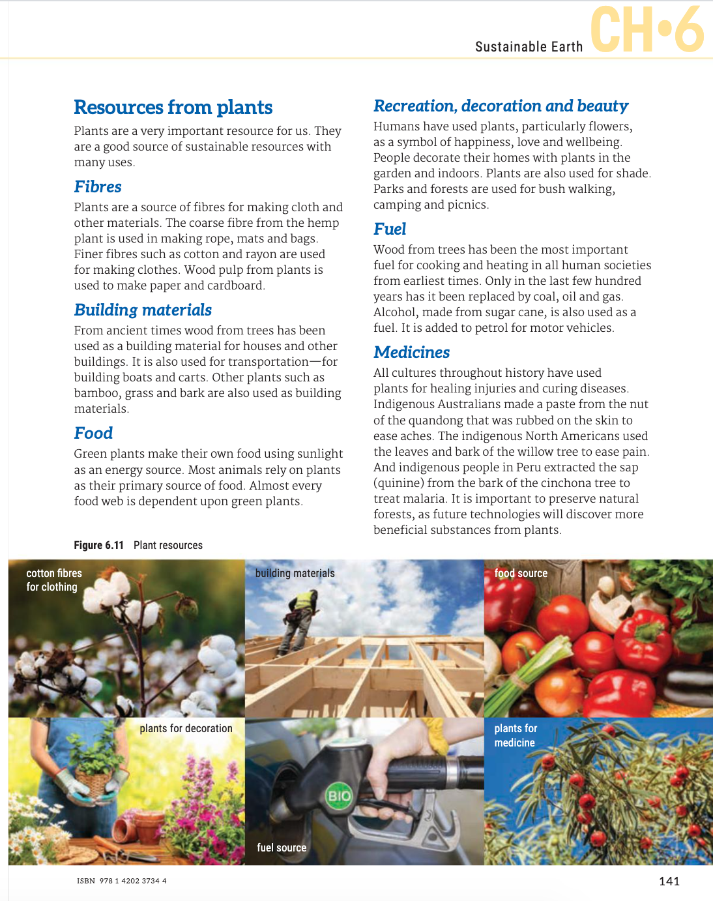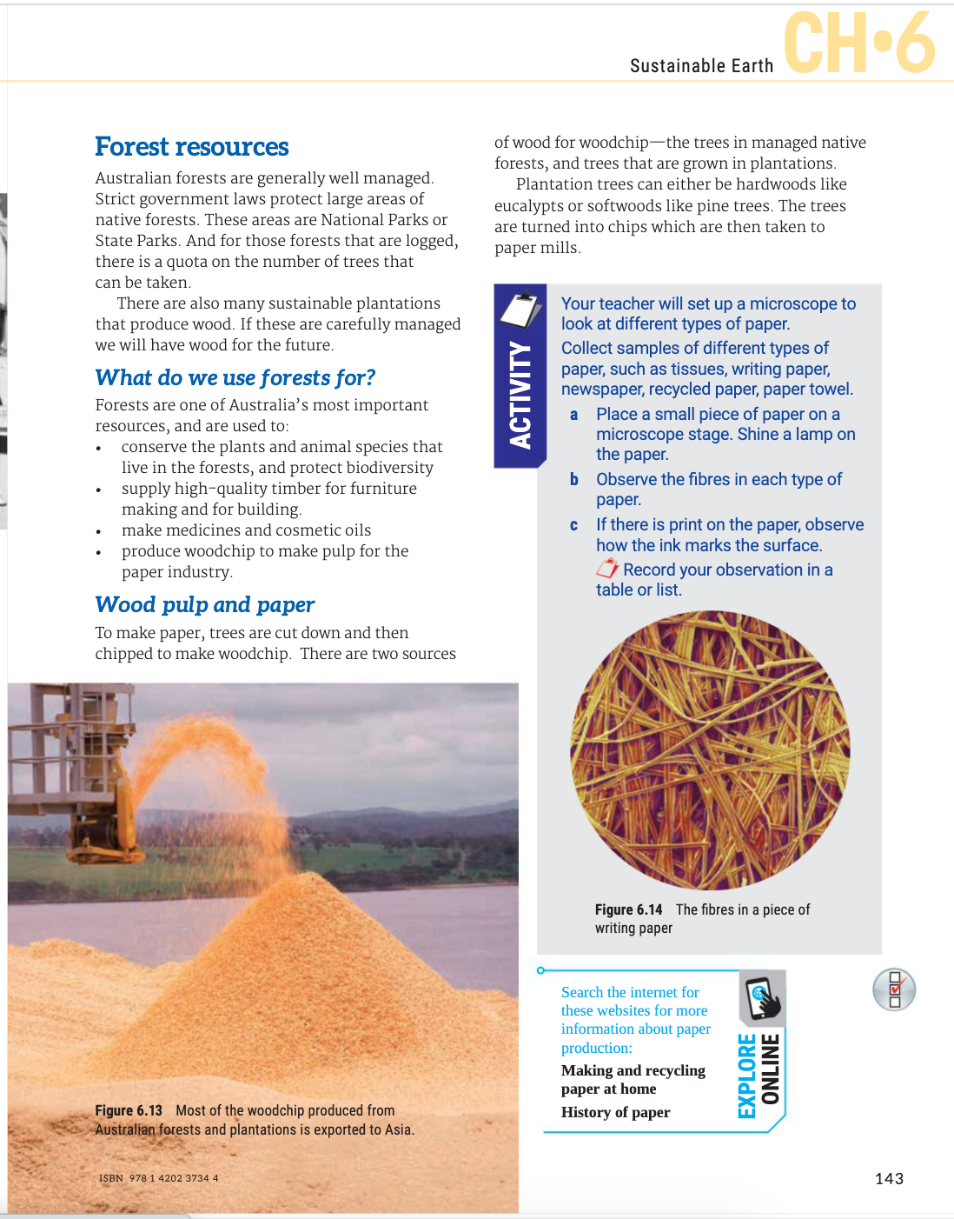

CHECK QUESTIONS
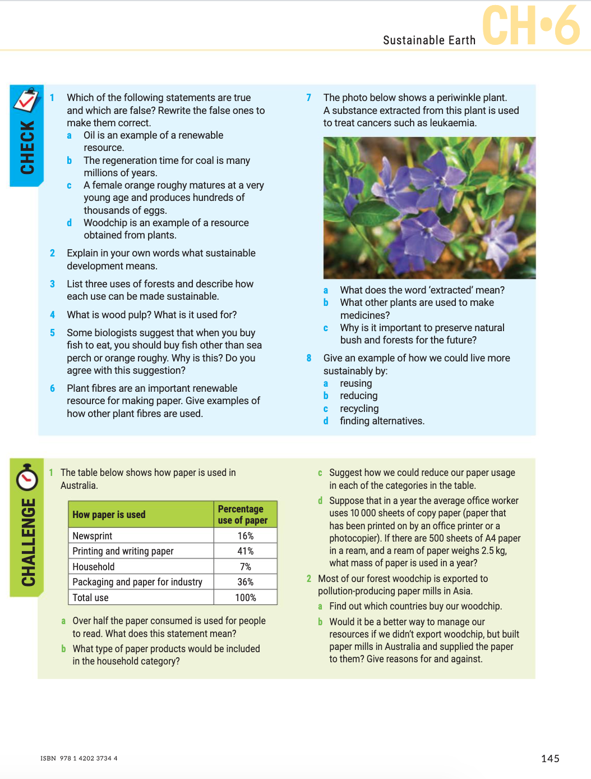

SCIENCE AS A HUMAN ENDEAVOUR
