Week: Term 2, Week 7
Day/Date: Monday 31st May – Tuesday 1st June 2021
Class: 7
Topic: Science (sustainable resources)

Completed | Suggested Time | Learning Activity | Student Action
Please note, all textbook pages referred to for this checklist have been provided in this word document.

 | 30 min | Sustainable resources - reading | - Read ‘6.2 Sustainable resources’ on pages 138 (top half of page), 139 (top half of page), 141 and 143.
 | 15min | Sustainable resources - activity | - Complete ‘Activity’ questions 1 - 4 (in the blue box on page 138)
 | 15 min | Science as a Human Endeavour – Sustainable fishing | - Read ‘Science as a Human Endeavour’ on page 140.  - Complete Questions 1-4.

READING AND ACTIVITY PAGES
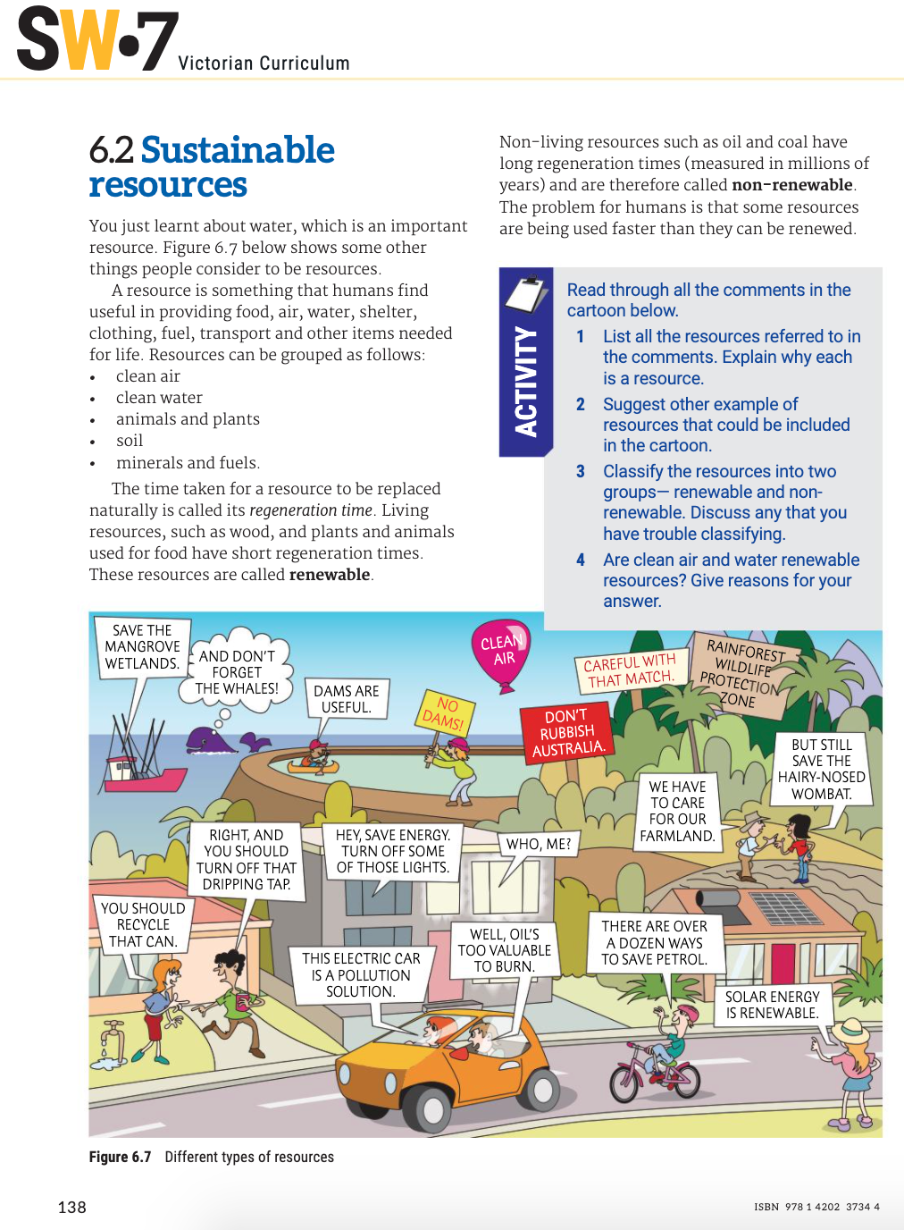
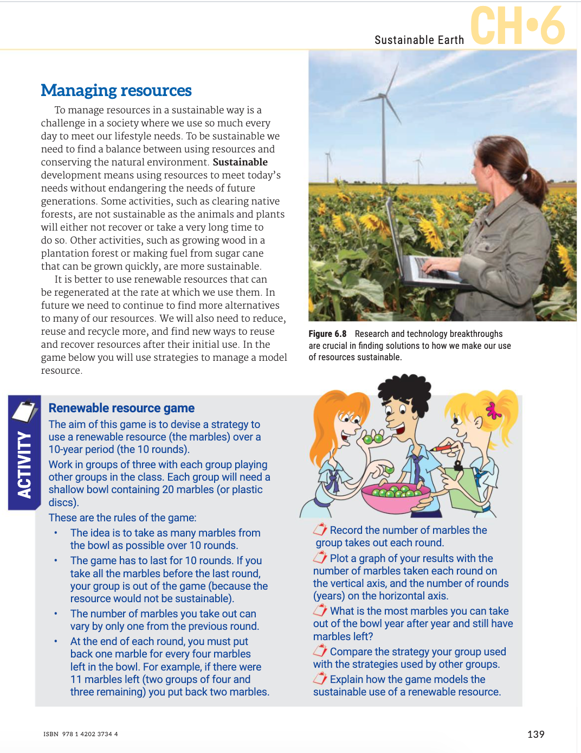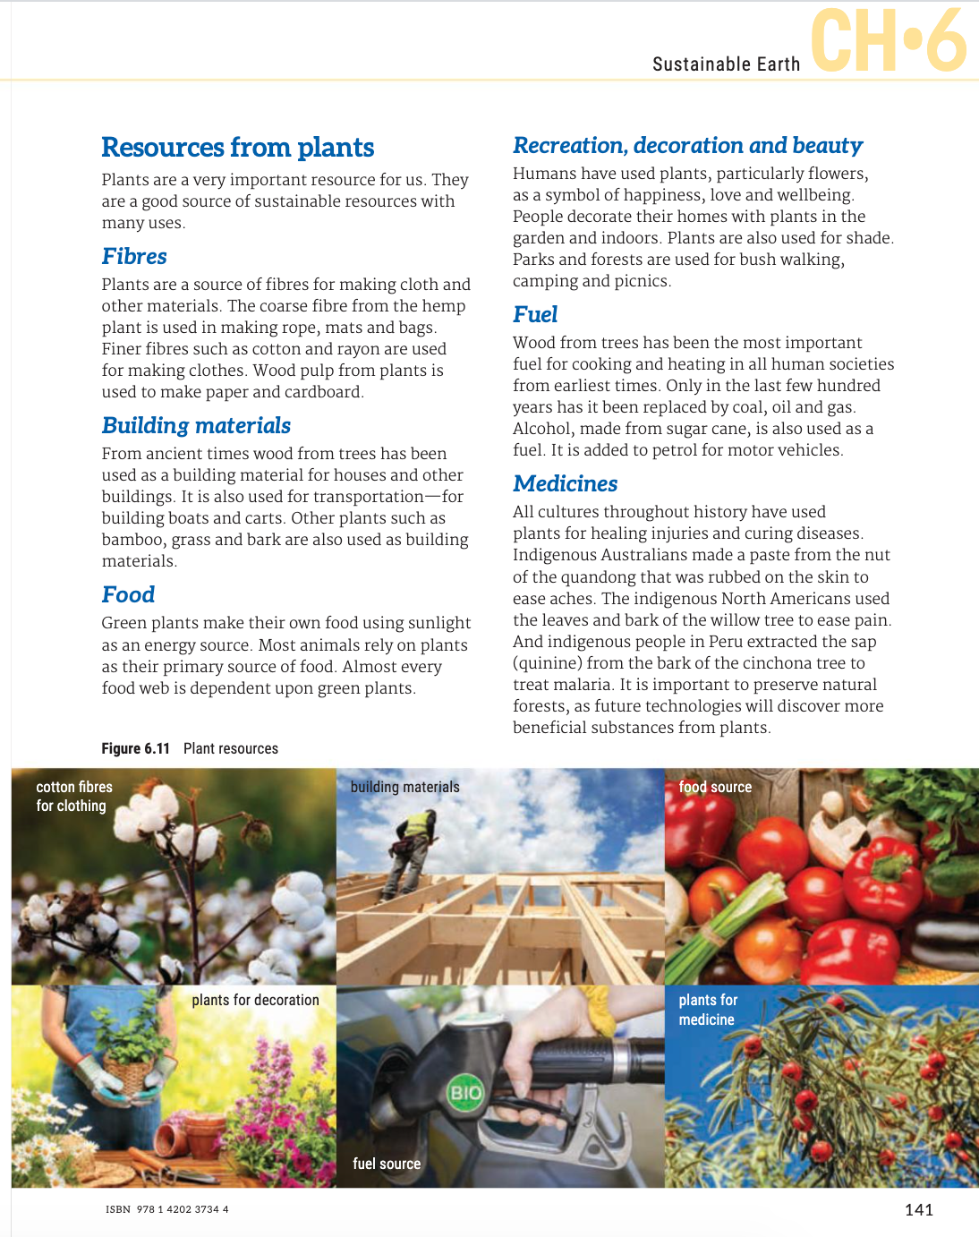

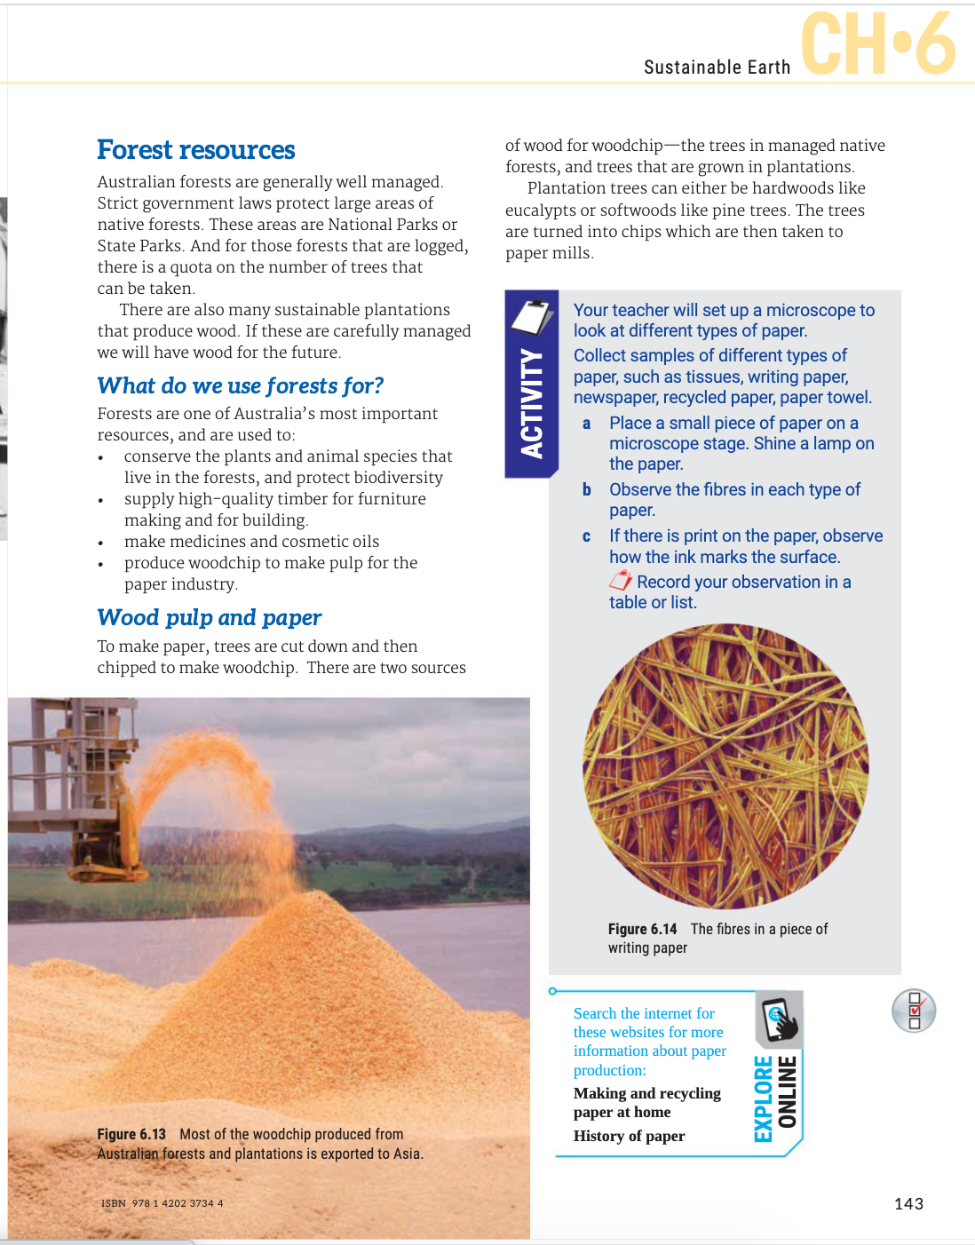

SCIENCE AS A HUMAN ENDEAVOUR
