Week: Term 2, Week 7
Day/Date: Wednesday 2nd - Thursday 3rd June
Class: 8 Science
Topic: Elements and Compounds

Completed | Suggested Time | Learning Activity | Student Action
Please note, all textbook pages referred to for this checklist have been provided in this word document.

 | 15 min | Check questions - Atoms | - Complete Check questions on page 184, for a recap of knowledge
 | 3 min | Element’s song  https://www.youtube.com/watch?v=uJGrwWOWt3Q | - Watch video and sing along!
 | 7 min | The story of Marie Curie  The genius of Marie Curie - Shohini Ghose - YouTube | - Watch the story of Marie Curie
 | 15 min | Science as a Human Endeavour – Fireworks | - Read ‘Science as a Human Endeavour’ on pages 191  - As a reflection;  - What is a pyrotechnician?  - When and where was the first time did you see fireworks?  - What is your favourite type of firework?
 | 20 min | Activity worksheet - Fireworks | - Please complete ‘Fireworks’ worksheet attached.
Additional task (optional)

 | 20 Min | Activity | - Complete activity questions on page 188

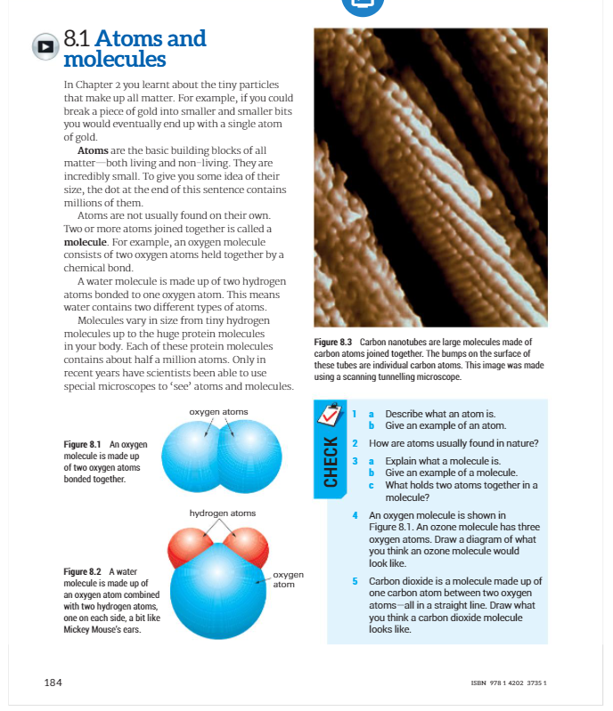

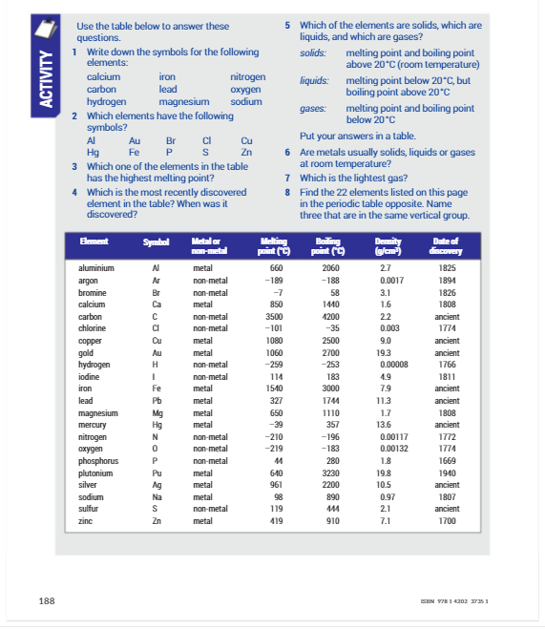

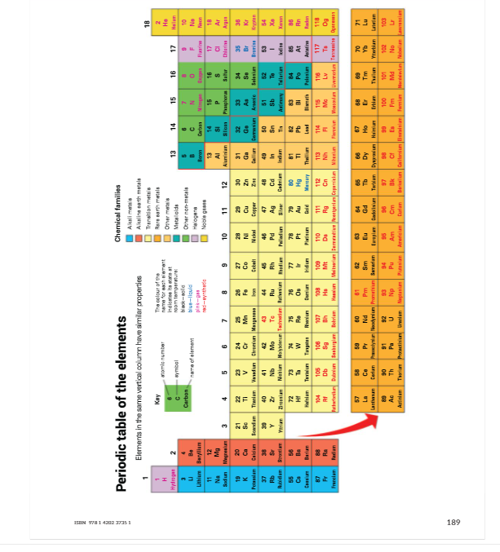
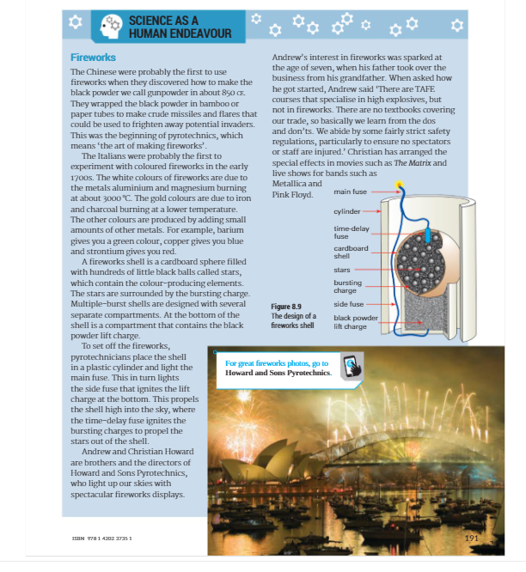

Fireworks

Chemical elements in fireworks
Chemical element | Symbol | Metal/Non-Metal? | What it does in fireworks
Lithium |  |  | Colour agent - red
 | Na |  | Colour agent - gold and yellow
 | K |  | Fuel and orange - red sparks; colouring agent - lilac
Magnesium |  |  | Fuel and bright white flames
Calcium |  |  | Colour enhancer - helps make colours deeper; colouring agent - brick red
 | Sr |  | Colouring agent - red (crimson)
Barium |  |  | Colouring agent - green
Titanium |  |  | Fuel and produces silver-white sparks
 | Fe |  | Produces gold coloured sparks
 | Cu |  | Colouring agent - blue/green
Zinc |  |  | Fuel and smoke agent
Aluminium |  |  | Fuel and makes yellow-white sparks eg in sparklers
 | C |  | Fuel, component of black powder
 | P |  | Fuel
 | Sb |  | Fuel, glitter effects
Sulfur |  |  | Fuel, component of black powder
Questions
1. Complete the Chemical elements in fireworks table (above) by adding the missing element names and symbols. Then work out and fill in which elements are metals and which are non metals. Use a Periodic Table to help you if necessary ( on page 189 Scienceworld 8 textbook).
2. Which chemical elements could be combined in a firework to make:
  - Turquoise (blue/green)?..................................................................................
  - Glitter effect? ………………………………………………………………………………………………
  - Gold and yellow?…………………………………………………………………………………………

3. Look at the photograph of fireworks. Which chemical elements can be seen?
……………………………………………………………………………………………………………….………………………………………………………………………………………………………………..……………………………………………………………………………………………………………….……………………………………………………………………………………………………………….………………………………………………………………………………………………………………………………………………………………………………………………………………………………………………………………..……………….

